**TEAM 19 PHASE 3**

TEAM MEMBERS WITH THEIR UTA IDS:

Anande, Saahil (1001855308)  
Pagare, Richa (1001873138)  
Sharma, Satvik (1001868047)

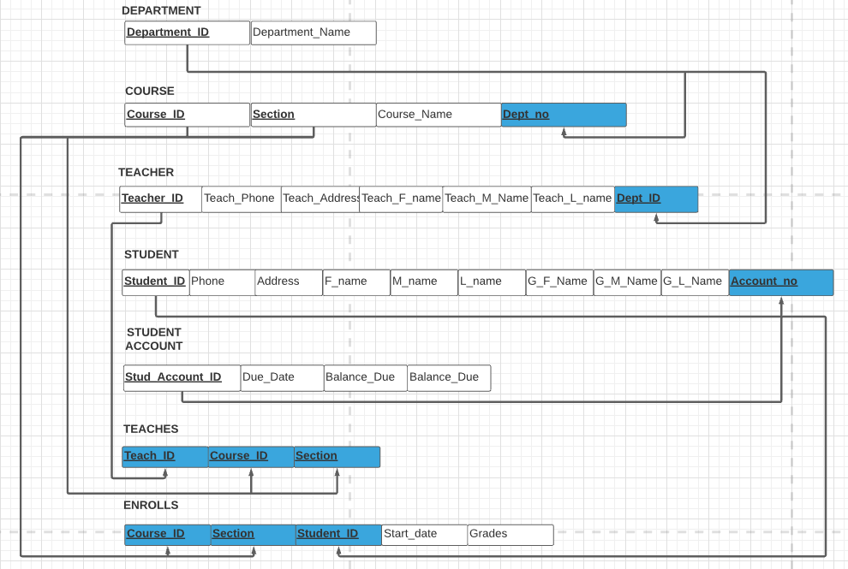

Below is a brief explanation about some of the relationships, and the relations.

Primary keys are underlined and the Foreign Keys are underlined and highlighted in blue.The department relation has Department ID has a primary key, and so on. Course has a 1:1 relationship with Department entity. So, the primary key of relation Department is merged into the Course entity as a foreign key.

Similarly, Teacher has a 1:1 relationship with Department entity. The relation Teacher has a primary key Teacher_ID. So, the primary key of relation Department is merged into the Teacher relation as a foreign key.

Since, the relationship between Teacher and Course is 0:N and 1:M, we form a **new relation Teaches**. Course_ID and Section together are the primary key for the relation Course, while Teacher has Teacher_ID has a primary key. The relation Teaches pulls both the primary keys from the relation Course as well as from Teacher entity which acts as the foreign keys (for relation Teaches.)

Since, the relationship between Student and Course is 0:M and 1:N, we form a **new relation Enrolls**. Course_ID and Section together are the primary key for the relation Course, while Student has Student_ID as a primary key. The relation Enrolls pulls both the primary keys from the relation Course as well as from Student entity which acts as the foreign keys (for relation Enrolls.)

The relation Student Account has Account_no as a primary key. It has 1:1 relationship with the relation Student. Hence, the relation Student pulls its primary key (Stud_Account_ID) from relation Student Account to serve as a Foreign key.